  ALLOTMENT NEWSLETTER  WINTER 2026 | WELCOME   We welcome the following new plot holders in 2026:  Plot 1 – Sarah Turley  Plot 10 – Gareth Williams  Plot 11 – Jasmine Lilley  Plot 13 – Jacqueline Tiltman  There are currently 13 HB residents on the waiting list. Anyone interested in an allotment should complete this form.
VOLUNTEER DAYS  We held two successful volunteer days at the end of last year to make repairs to the car park and prepare the Nectar Bar for winter.  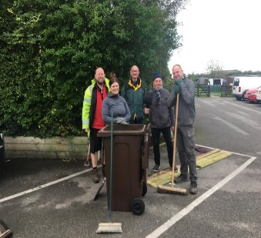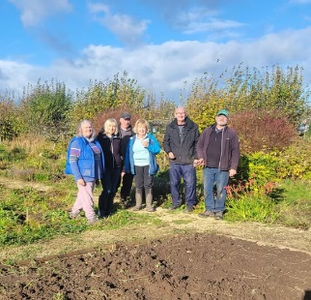  We rely on volunteer days (plus some stalwart plot holders) to keep our site looking beautiful for the wider community. The site rules state: each plot holder will be expected to contribute to the general upkeep of the entire site. The Committee will decide annually on works to be carried out. Plot holders, at the discretion of the Committee, may opt to have a friend or relative carry out their portion of a work.  Volunteer days will become a regular occurrence in 2026, and we would encourage everyone to join in. A brew and a biscuit will be available for all volunteers. These will take place 10-12am on the third weekend of each month and the committee will maintain a list of jobs that need completing.  The first task is to complete the works we have funded from a successful Lancashire Environmental Fund bid so please join us on 15 February at 10am.   | COMMITTEE ACTIVITY   Minutes of all committee meetings are available on our Website.  - We have completed a risk assessment of the site to support volunteering days.  - We have produced a complaints policy which is now available on our website.  - We are reviewing our Trust Deed with the Parish Council and Site Rules for discussion at AGM.  - Produced a NoDig and nature article on page 2 of this newsletter.  Mel and Carol have stepped away from the committee for personal reasons. We would like to say a massive thank you for their support over several years. If you’re interested in joining the committee, please get in touch.
THANKS 
Thanks to all the plot holders who do tremendous work throughout the year to keep our site looking fantastic.

WHAT’S ON 
- 15 February 2026 – Volunteer Day, 10am on site
- 27 February 2026 – Plot Holder Social, 7pm at Hesketh Bank Bowling Club
- 7 May 2026 – Annual General Meeting, 7pm at Hesketh Bank Community Centre
- 5 July 2026 – Mikron Outdoor Theatre, 2pm on site
- 29 August 2026 – Summer Show, 1pm on site

We will be taking a break from the Scarecrow competition this year but will still seek local charity donations at the Summer Show.
 Keep updated on our Website and on our Facebook page

Let us know what you would like to see included in the next newsletter?

🌱 NoDig Allotments: A Better Way Forward?
The Poor Marsh Allotment site faces the same challenges many growers across the UK know all too well: heavy weeds, tired soil, and the sheer physical effort of digging over large plots. But there is a gentler, more productive approach gaining momentum - NoDig gardening - and it could transform the way you grow.

🌿 What Is NoDig?
NoDig gardening is exactly what it sounds like: instead of turning the soil, you simply add organic matter - like compost or well-rotted manure - on top and let nature do the rest. According to the RHS, this method improves soil health, reduces the need for fertilisers, and supports the natural ecosystem beneath our feet. It mimics woodland floors, where leaves fall, break down, and feed the soil without disturbance.

🌾 Why It Works So Well on Allotments
Allotments often come with compacted soil, deep-rooted weeds, and limited time to manage them. NoDig directly tackles these issues:
- Less Weeding: Mulching with compost or cardboard blocks light and suppresses weed growth, a method proven effective even on plots overrun with perennial weeds.
- Better Soil Structure: By avoiding digging, worms and microorganisms thrive, naturally improving drainage and fertility.
- Less Work: NoDig is ideal for gardeners who do not have the time - or the backs - to dig over large beds every season.
- Higher Yields: Many growers report stronger, healthier crops thanks to the improved soil ecosystem.

🌼 How to Get Started
Starting NoDig on a new or overgrown plot is surprisingly simple:
- Lay down cardboard over the entire bed area to smother weeds.
- Add a thick layer of compost - homemade, green waste, or well-rotted manure.
- Plant directly into the compost layer, letting roots grow down into the soil below.

🌍 A Sustainable Future for Poor Marsh
NoDig is not just easier - it is environmentally friendly. It reduces soil erosion, cuts down on fertiliser use, and supports biodiversity. For allotment sites like Poor Marsh, adopting NoDig could mean less labour, fewer weeds, healthier soil, and more abundant harvests.

It is a simple shift with big rewards. And the best part? Anyone can start today - no spade required. For more information you may want to look at the Charles Dowding website or the RHS website.

 Nature News

Spring starts soon!
After a what seems to be long and cold winter the Spring seems still far off as February usually has the coldest spells of winter. However, bird life seems to be waking up with great tit, thrushes, and robins singing on territory, while wood pigeons are building nests. There have been regular sighting of buzzards, kestrel and sparrow hawks over the site. Little egrets feed in the ditches in the colder snaps and tawney owls call most nights.

Insects
There are no insects in winter is a common belief, but if you keep a little area untidy, it will be full of beneficial invertebrate usually in dormant forms such as caterpillars. The pictured moth was on the wing in January so keep your eyes out on warmer days for reawakening butterflies.

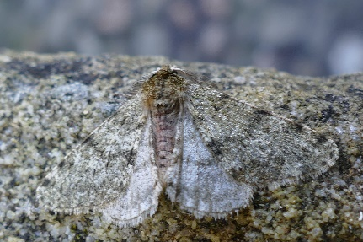  Pale Brindled Beauty Phigalia Pilosaria | Sighting records  There is a database of sightings on the site so please contact me on 01772813772 or robj.yates@btinternet.com if you see anything.

