Hesketh Bank Poor Marsh Allotments – Strategic Plan 2024-26

Created by | Date last reviewed
Jenni Smitton - Chair | 31 December 2023
Executive Summary
This strategy sets out our commitment to the Hesketh Bank Poor Marsh allotments for the next 3 years. In this strategy we identify:
- What we want to achieve for current and future plot holders
- How we will work with plot holders and members of the local community
- The resource implications of our strategy and how we plan to secure funding.
Vision Statement
To deliver a site to current and future plot holders that is well managed and maintained and highly valued by us and the local community. Maximise the opportunities for our community to enjoy the experience and benefits that allotments can provide.
Why are allotments important?
We have long valued allotments as the green beating heart of the community because we recognise that they help to deliver the following benefits:
- Health improvement: Gardening is often recommended as a suitable form of exercise and can help prevent health related problems. We have an ageing population and, nationally, a quarter of the population was over 60. In later life, physical activity has an important role to play in maintaining functional ability, preventing disability and isolation and promoting independence. Allotments have traditionally been enjoyed by older people and have an important role to play in helping older people participate in exercise.
- Positive mental health: Allotments help people get out of their house, give them a focus and the opportunity to be part of a social group whilst developing a sense of ownership. They allow residents to socialise, make friends and become part of the wider community or enjoy solitude in a safe environment. Gardening is also recognised as being useful in stress relief and relaxation.
- Healthy food: Growing your own vegetables and fruit can be relatively cheap, and it can be a distinct advantage for those who are feeling the pinch of economic downturn, have an interest in fresh food or would like to reduce food miles or their carbon footprint. Evidence strongly suggests that the type and amount of food we eat plays an important role in our health.
- Bringing communities together: Allotments attract people from all backgrounds and can help promote community cohesion. The Local Government Association Growing in the Community guide states that “allotments have a distinctive contribution to make to the achievement of social inclusion at local levels, as communities of interest bring in a wide range of people, including people from different gardening traditions and cultures, together for a common purpose.”
- Biodiversity: Many cultivated allotments make a distinctive contribution to local biodiversity. Natural features, including hedges and mature trees can make working allotments a wildlife haven. Compost heaps are also mini biodiversity centres in their own right. Insects and other invertebrates as well as hedgehogs are attracted to compost heaps as they require shelter when not active. In turn, insects attract birds and other wildlife into the allotment; some plot holders have set aside a small area within their plot for wildlife.
- Education: People engaged in gardening learn to use many skills. Whilst horticulture is the obvious one, community and social skills are also developed. More experienced allotment holders enjoy sharing their knowledge with newcomers. Allotments and the principles can help in educating children within all key stages across many curriculum areas. Additionally, they can deliver lifelong 'experiential' learning - via extended schools, family learning and intergenerational teaching and learning.
Our Site
The current Community Garden was opened in 2010 creating approx. 60 manageable plots, encircling a central area of about an acre, designed to provide an attractive and wildlife friendly area for the community to enjoy. The site features a path, seating, an apiary, an orchard, a pond, bug hotel and a wildflower garden.

A beautiful Peace Garden has been added next to the car park at the front of the site and is kindly maintained by several plot holders.

Annually, the site plays host to the Mikron Travelling Theatre Company delivering a wonderful outdoor show. There is also a Summer Show and Family Fun Day with lots of fun events for all. For the last two years a Scarecrow Competition has proved very popular and is likely to become an annual event.

We have successfully bid for and received grants to invest in the site and our community events are increasing revenue for reinvestment.
Current Provision
Our current site (Annex A) consists of:
54 full plots and 10 half plots plus the communal area, peace garden and a car park

The site is currently full and a waiting list of potential plot holders is held by the committee. The waiting list is comprised of Hesketh Bank residents only.

Fees for 2024/25 are:
£45 full plot
£30 half plot
£4.50 co-worker
Strategic Aims
As part of this strategy, we have identified three strategic objectives that we aim to achieve in order to deliver our ambition:
- To maintain and improve facilities and ensure the site is safe, welcoming and accessible to all
- To promote the benefits of allotments to local residents, schools and the whole community
- To make the most of the resources available to the site and deliver value for money for plot holders.

A Strategic Action Plan setting out how we will achieve these objectives is at Annex B. This will be supported by an annual project plan to ensure works are completed on time and within budget. The project plan will be monitored at monthly committee meetings which take place on the first Thursday of every month.

Annex A Allotment Site – December 2023
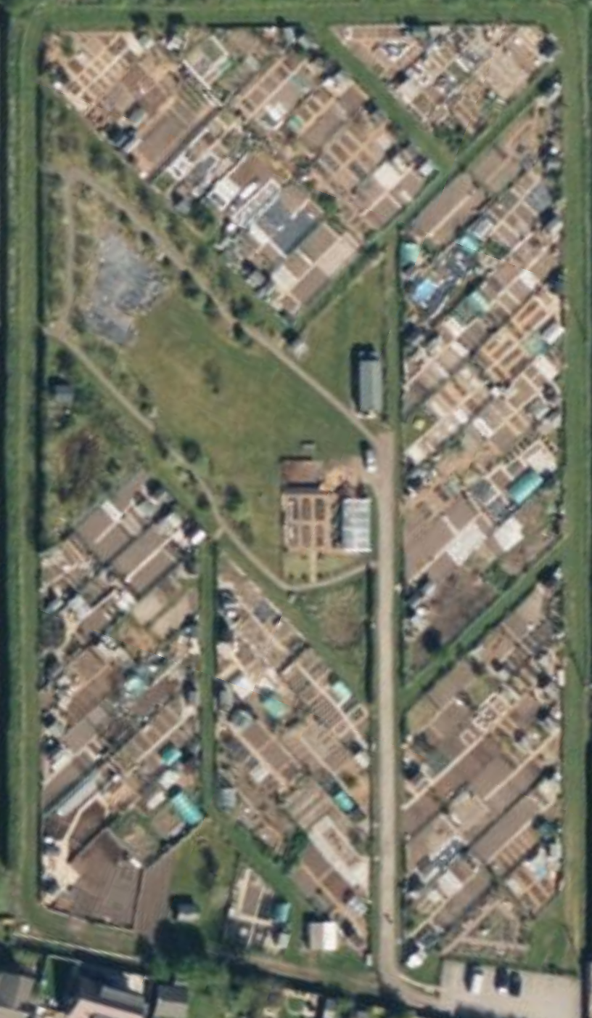
61
58
59
Pond
Bog
Apiary
Peace Garden
Polytunnel
Orchard
Nectar Bar

37
39
41
43
44
42
40
38
56
54
52
50
48
46
45
20
22
60
23
21
19
17
15
13
11
9
18b
18a
16
14
12
10
8
6
7
5
4
24b
24a
3b
3a
2
1
25a
25b
26
27
28
36
35
34
33
32
31
30
47
49
51
53
57
55

Annex B 2024-26 Strategic Action Plan

- To maintain and improve the facilities and ensure the site is safe, welcoming and accessible to all
Ref | Action | Timescale | Person responsible | Comments | Date complete
1.1 | Set aside funds for maintenance of car park should these be required | 2024 | Treasurer | £X in reserve as of 31 December 2023.  Obtain 3 quotes for resurfacing/repairs to ensure reserves are sufficient
1.2 | Consider improvements to enable better disabled access to the site | 2024 | Committee | Obtain 3 quotes for improving disabled access to site.
1.3 | Ensure the communal areas are well maintained, well managed and environmentally friendly | Annual | Committee | Site maintenance plan to October 23 meeting  Put in place a register of equipment  Arrange future management of apiary  Consider opportunities to be more insect friendly – refresh bug hotel  Refresh signage on site
1.4 | Ensure appropriate governance is in place and the rules are clear for all plot holders | 2024 | Secretary | To agree new set of rules at EGM and ensure inspection process is transparent to all plot holders
1.5 | Carry out annual inspections to ensure the whole site is well maintained | Annual | Committee | 2024 inspections in June, August and October

- To promote the benefits of allotments to local residents, schools and the whole community
Ref | Action | Timescale | Person responsible | Comments | Date complete
2.1 | To host annual scarecrow festival | Annual | Committee | 2023 event a great success with £241 raised from refreshments. 2024 event to take place on 22 June with the theme of nursery rhymes and children’s books. Donations to Derian House.
2.2 | To host annual summer show | Annual | Committee | 2023 event record breaking with £1,480 raised. 2024 event to take place on 31 August.
2.3 | To provide site visits for local schools | Annual | Chair | Emailed all local schools on 4 September 2023  Email again in February 2023 | 07/09/23 Banks Methodist
2.4 | To host Mikron theatre annually | Annual | Committee | 2023 event a great success. 2024 event to take place on 7 July.
2.5 | Increase our social media presence and consider developing a website | 2024 | Chair | FB already set up and recording social media activity  Update branch of Parish Council website including key documents and form to apply for allotment

- To make the most of the resources available to the site and deliver value for money for plot holders
Ref | Action | Timescale | Person responsible | Comments | Date complete
3.1 | Apply for relevant grants as they become available | As required | Treasurer | Received £500 in 2023 for new benches
3.2 | Seek funding from Council for specific works | As required | Treasurer | Submit bid to Council to improve disabled access
3.3 | Explore organisations willing to donate to site | Annual | Chair | Registered with Neighbourly  Chair to contact local businesses for donations to future events
3.4 | Generate income for reinvestment in site from our community events | Annual | Committee | Income from events to be used to purchase new marquee for fruit & veg show and equipment updates
3.5 | Ensure funds are reinvested in the site | Annual | Treasurer | Funds set aside for maintenance and equipment

